WEBSITE SPECIFICATIONS
- OBJECTIVES
Providing customers with an online platform that enables customers to make appointments to minimize walk-ins and waiting queues for services. This also minimizes congestion in the salon.
- GOALS
- Increase bookings: to convert website visitors into customers.
- Clear functional schedules: to helps employees/professionals to work knowing services needed, tools and demands of a customer. This also helps a professional to focus on one client at a time.
- Full customer experience: Providing a customer with relaxation and comfort rather than the stressing them out with waiting in lines to get a service. This also helps to prepare for their service demands on time respecting their time.
- Operational capacity: Ability to accommodate all reservations made and attending them well on time.
- TARGET AUDIENCE
Professionals and individuals with limited time or tight schedules and they value time as well as efficiency.
- DEMOGRAPHICS
- Age: 21- 65 years old
- Occupation: entrepreneurs, professionals, parents and students.
- Income level: Midrange to high level income
- Location: Urban areas and suburban areas
- Principles: Punctual, values efficiency and looking for self care in beauty and relaxation.
- TECHNICAL APTITUDE
Website is easy to navigate through and does not require any technical skill. It just requires one to have a smart device (smartphones, tablets and laptops) and be connected to the internet. The website works like ecommerce websites but does not require one pay at time of booking. This website makes it easy for one to handle cancellation steps without needing to call. Also, it sends emails to confirm ones bookings.

- WEBSITE TYPE
Online booking system that is like e-commerce. It awaits reservations to be done which are manually processed and allows the user to view service packages before making reservations. It also allows customers with special needs to ask for manual processing.
- CONTENT FOR THE USER
- Navigation bar;
- Home: Introduces the brand name, contains the welcome remarks and introduces the page to user. Not only that it has a location finder for a specific branch in your location. A snippet of the services provided and carousel showing some of the work done in the salon.
- Services: a detailed page on the services provided. This page shows categories in full.
- Policies: shows rules for the salon and the cancellation policy.
- Gallery: a portfolio showcasing our work.
- Footer: it has contact details for inquiries and complaints. Also, it includes a ‘Book now’ button that now allows user to open and fill in their appointment details. This detail allows user chose their own preferred professional and the website allows user to see time estimation on their preferred services.
- Operating hours: allows user to check for our availability at any time.

INFORMATION DESIGN AND TAXONOMY
- Information design
The website is designed in a way that navigation buttons stay persistent across all pages. The global navigation stays at the top of every page making selection easy since it cancels the need to go to the home page access a certain page. It also reduces time taken in the website to find a specific thing and provides efficiency.
- TAXONOMY
The content is arranged in a way that services are grouped with similar or the same content.
For instance, under hair, we have all hair services e.g coloring, plaiting and haircuts.
- SITE MAPPING
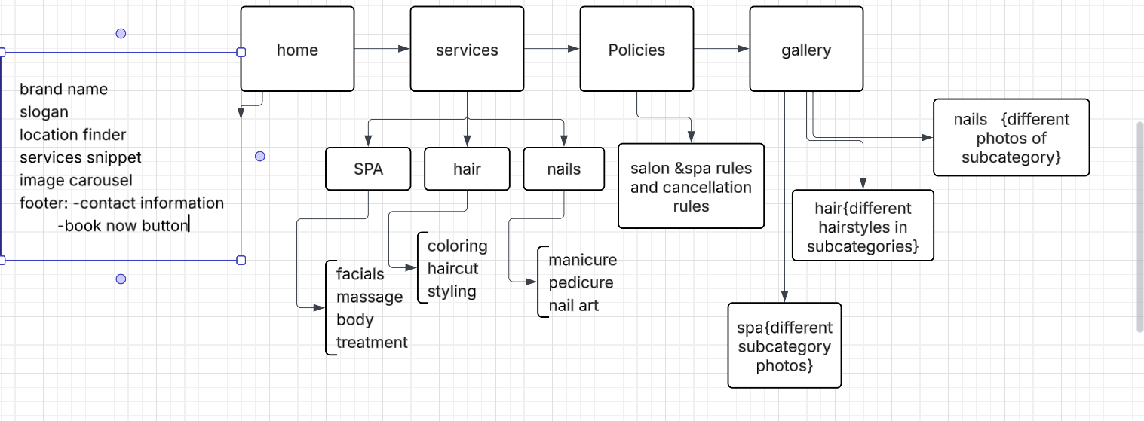
- Flowchart
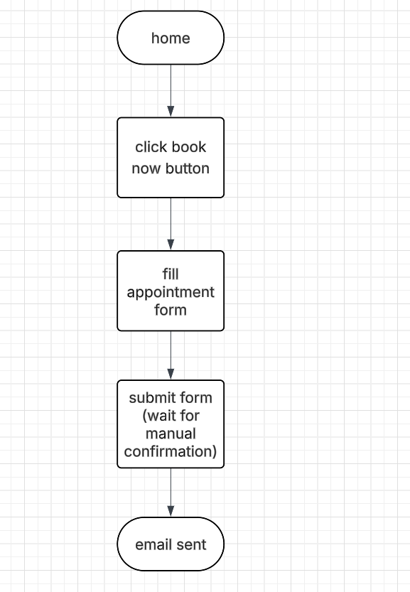

TECHNICAL BRIEF
To develop and build the LUXE SALON & SPA I will need the following technologies;
- Graphic and design tools:
Canva: to create and edit logos and my gallery photos.
- Development tools
- Visual studio code: use it a primary code editor to write html and CSS.
- GitHub: hosting my website, deployment using git pages
- Software tools
- Html: creating the layout of the website and structures
- CSS: styling the page and making sure the design is responsive and ensuring the website is working fine across all devices(friendly)
- JavaScript: makes sure the elements are interactive e.g the location finder.

